**Part 1: Recent Advancements in AI**

**1.1 Natural Language Processing (NLP) – Large Language Models (LLMs)**  
One of the most exciting breakthroughs in AI today is the rapid development of large language models (LLMs), such as OpenAI’s GPT-4. These advanced models are designed to help machines understand and generate human language in ways that were previously unimaginable. By training on vast datasets, LLMs can engage in conversations, mimic human speech, and even assist with highly specialized tasks. For instance, platforms like ChatGPT utilize these models to hold interactive dialogues with users in a natural, intuitive manner.

This innovation is groundbreaking because it enables AI to perform tasks that were once beyond the reach of earlier technologies. LLMs can now write essays, generate detailed summaries of complex books, provide translations, and even assist in programming by writing code. As these models continue to evolve, the future holds immense potential for their application in diverse industries, including customer service, content creation, and healthcare, where they could provide real-time assistance, generate creative content, or even assist medical professionals with diagnostics and research.

**1.2 AI in Healthcare – Diagnosing Diseases**  
Another significant area where AI is transforming industries is healthcare. AI systems, such as the one developed by Google, have made tremendous strides in improving the accuracy and speed of disease diagnosis. By analyzing medical images, like X-rays or MRIs, these systems can detect subtle abnormalities that may be too minute for human eyes to discern. For example, Google’s AI has demonstrated impressive accuracy in diagnosing breast cancer from mammograms, providing a valuable second opinion to healthcare professionals.

This advancement holds the potential to revolutionize how we approach healthcare, as it enables earlier detection of diseases, which is critical for improving patient outcomes. As AI becomes a trusted tool in medical diagnostics, we may soon witness its regular integration into hospitals and clinics, assisting doctors in making faster and more accurate diagnoses while reducing the chances of human error. In the coming years, AI-driven diagnostic systems could lead to more personalized care and better treatment plans for patients.

**1.3 Autonomous Driving – Self-Driving Cars**  
Self-driving cars represent another remarkable development in the field of AI, particularly in robotics. Companies like Tesla and Waymo are at the forefront of this innovation, using AI to enable cars to "see" and interpret their surroundings. These vehicles rely on a combination of cameras, sensors, and machine learning algorithms to make complex decisions in real time—such as recognizing pedestrians, avoiding obstacles, and determining the safest route.

The importance of this technology cannot be overstated, as it holds the promise of dramatically improving road safety and reducing traffic-related accidents. By eliminating human error—one of the leading causes of accidents—self-driving cars could save thousands of lives each year. In the near future, autonomous vehicles may become a common sight on our streets, reshaping urban transportation and providing greater convenience for commuters. Additionally, this technology could significantly reduce traffic congestion, enhance fuel efficiency, and lower carbon emissions, contributing to a greener and more sustainable future.

**Part 2: Comparing AI Regulations in Australia and the EU**

**2.1 Australia’s AI Governance**  
Australia has adopted a pragmatic approach to AI governance, focusing on balancing innovation with safety and ethics. Rather than imposing overly restrictive regulations, the country aims to foster an environment that encourages technological advancement while managing the inherent risks associated with AI. This approach is particularly important in sectors such as healthcare and finance, where AI can have profound implications. Australia’s regulatory framework emphasizes the ethical use of AI, ensuring that these systems are transparent, fair, and accountable, while still allowing room for innovation and growth.

**2.2 The European Union’s AI Act**  
In contrast, the European Union has taken a more stringent approach to AI regulation, particularly with the introduction of the AI Act. This legislation categorizes AI technologies based on their potential risk to individuals and society, assigning stricter rules to those deemed high-risk. For example, AI systems used in facial recognition or critical infrastructure are subject to rigorous oversight and compliance requirements. The EU’s regulatory framework prioritizes safety, transparency, and the protection of individual privacy, ensuring that AI systems operate in a manner that respects fundamental rights.

**2.3 Creative Comparison**  
To draw a creative comparison, if AI were a superhero, Australia’s regulations would resemble the sidekick—supportive, offering guidance, and allowing AI to explore its full potential with minimal interference. In contrast, the EU would be the strict, vigilant guardian, ensuring that AI follows every rule and makes cautious, well-thought-out decisions. Imagine AI trying to take over your smart fridge; while the EU’s regulations would likely prevent any unexpected actions, Australia’s laws might allow more flexibility but step in with advice when necessary to fix any issues quickly. This comparison highlights the differing approaches, with the EU focusing on stringent safeguards and Australia offering a more flexible, innovation-friendly stance.

**Part 3: Future Trends in AI**

**3.1 AI as Co-workers**  
One of the most fascinating future trends in AI is its increasing role as a co-worker. Today, many companies already rely on AI for routine tasks such as answering customer queries, automating data entry, and analyzing large datasets. However, in the next five to ten years, AI is expected to take on even more complex responsibilities, including decision-making roles. This could lead to significant changes in workplace dynamics, as AI may not only support human workers but also collaborate with them to solve problems and optimize business processes.

As AI becomes more embedded in the workforce, both Australia and the EU may need to revisit their regulations to address new challenges. For instance, questions about accountability will arise—who is responsible when AI makes a mistake? Additionally, there will likely be discussions about the ethical implications of AI replacing human jobs and how to ensure that AI enhances, rather than diminishes, the human workforce.

**3.2 AI in Everyday Devices**  
Another trend that is gaining momentum is the integration of AI into everyday household devices. We are already familiar with smart assistants like Amazon’s Alexa or Google Assistant, but the future holds even more possibilities. AI could soon control many aspects of our daily lives, from managing groceries and scheduling tasks to monitoring our home environments and making personalized adjustments to things like temperature and lighting.

As AI becomes more pervasive in our homes, regulatory frameworks in both Australia and the EU will need to evolve to ensure that personal data remains secure and that AI technologies are trustworthy. With more devices collecting and analyzing our data, privacy concerns will become increasingly significant, and governments will need to establish clear guidelines to protect consumers from potential misuse of AI technologies.

**References**

Australian Government. (2023). AI Governance and Ethics Framework. <https://www.industry.gov.au/data-and-publications/ai-ethics-framework>

European Commission. (2023). Artificial Intelligence Act: Ensuring AI is Safe and Human-Centric. <https://ec.europa.eu/digital-strategy>

Smith, J. (2022). Advances in Natural Language Processing: The AI

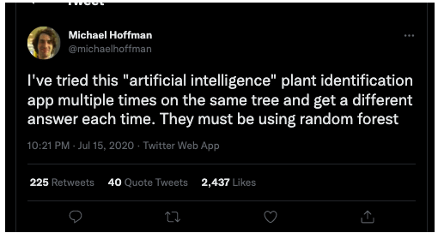

Michael Hoffman. (2020, Jul 15). I've tried this "artificial intelligence" plant identification app... Twitter. <https://datasciencedojo.com/blog/top-ai-memes-and-jokes/>

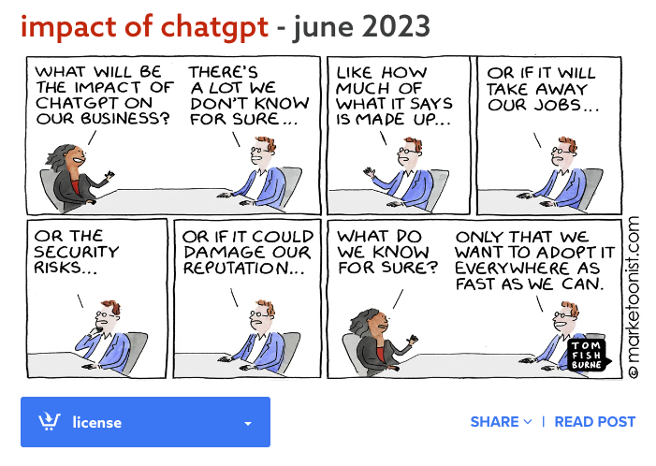

Fishburne, T. (2023, January). AI tidal wave. Marketoonist. <https://marketoonist.com/2023/10/ai-and-the-future-of-work.html>

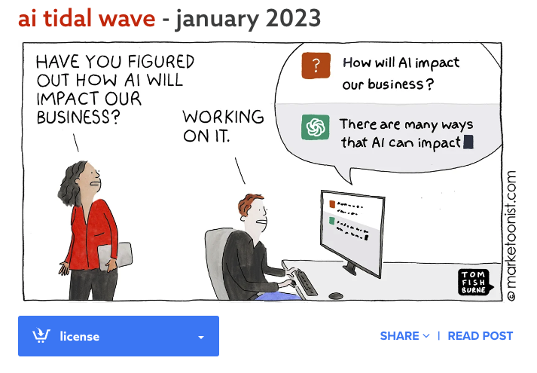

Fishburne, T. (2023, January). AI tidal wave. Marketoonist. <https://marketoonist.com/2023/10/ai-and-the-future-of-work.html>